**K8 Services:**

**What is a service?**

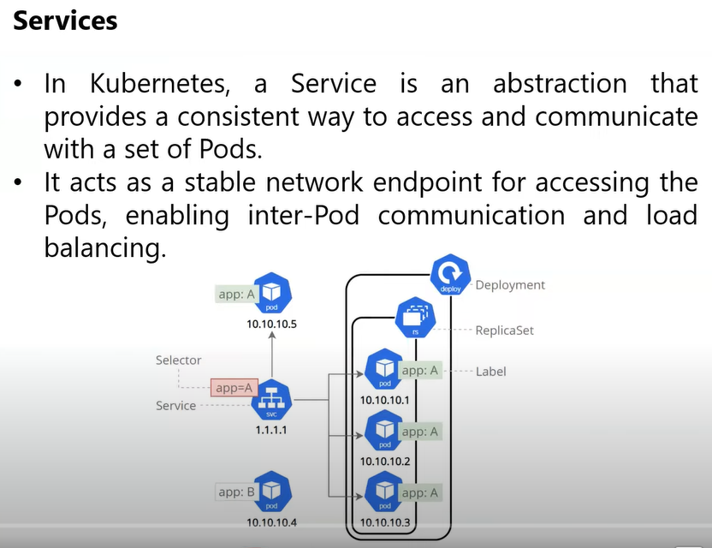

**Note:** whenever a pod gets delete in the cluster, the ip address to that pod also deletes and the new pod will be created with new ip address.

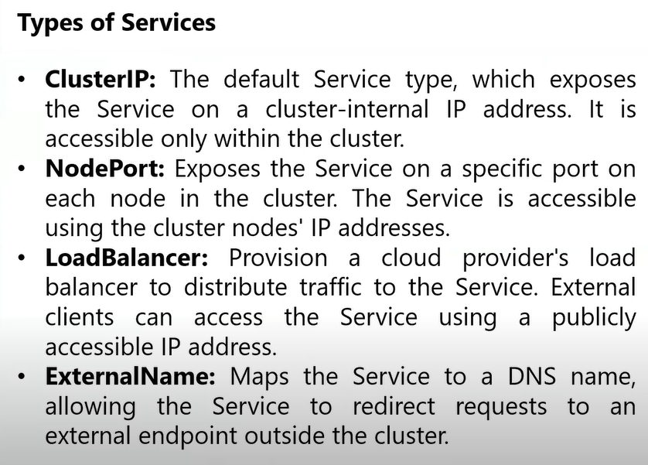

**Cluster IP:**

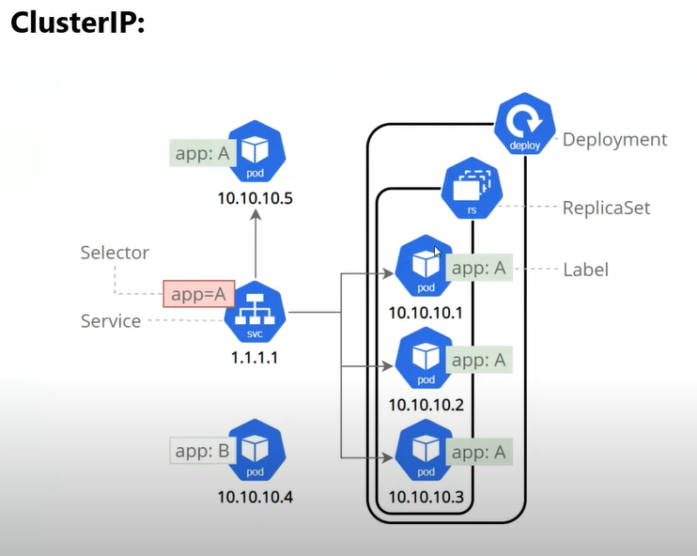

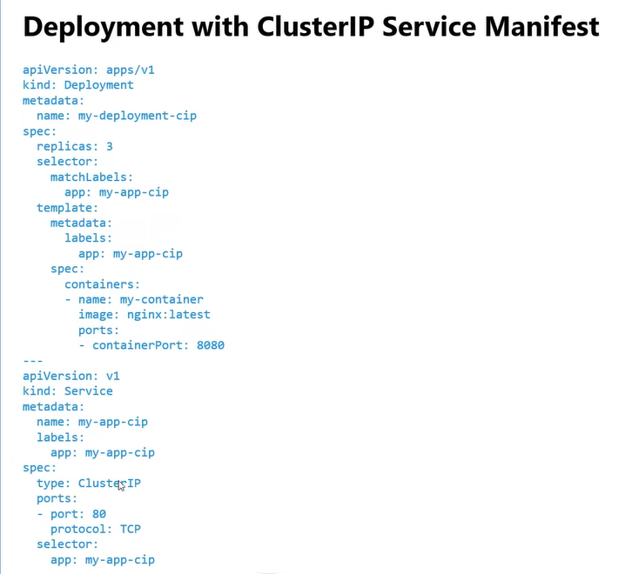

**Nodeport:**

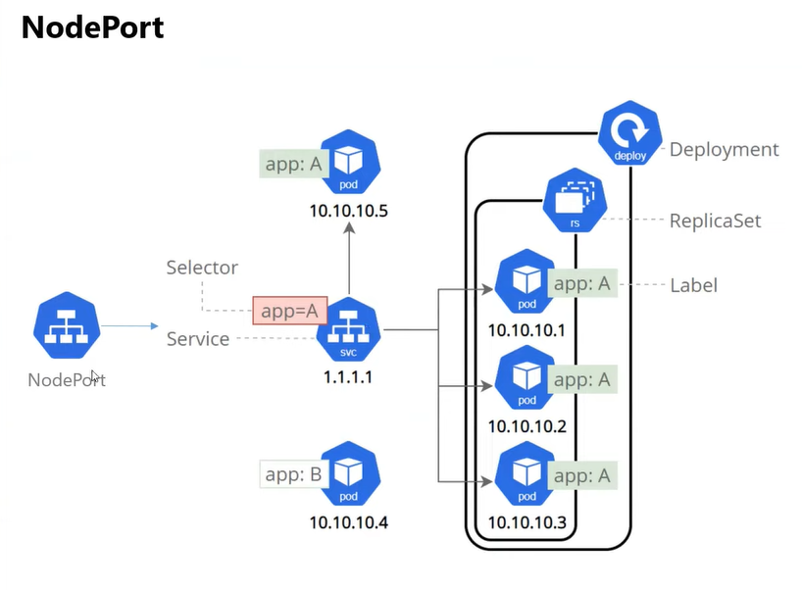

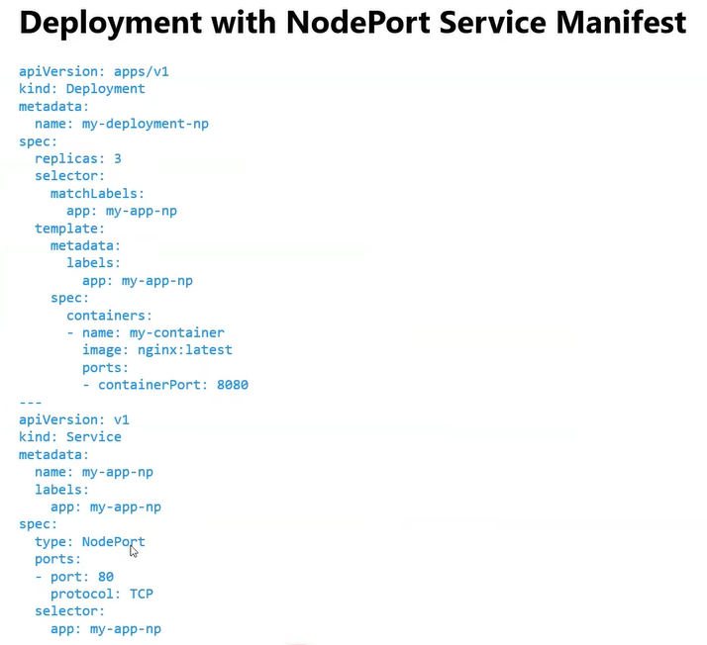

**LB:**

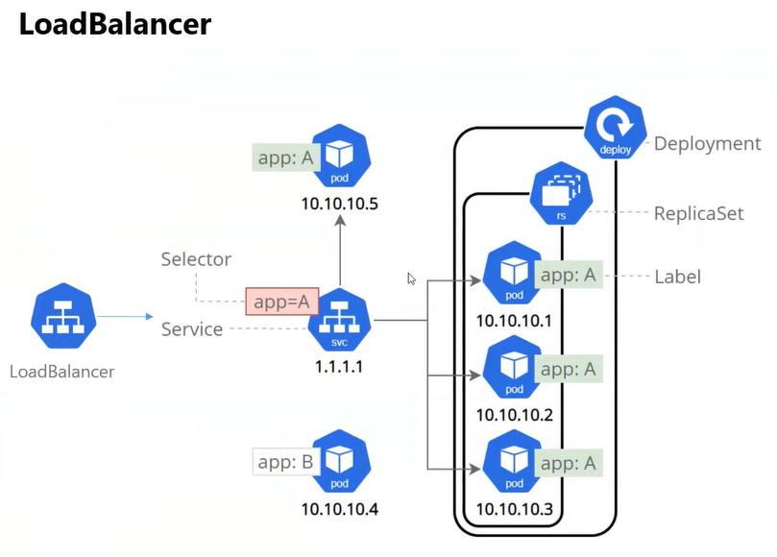

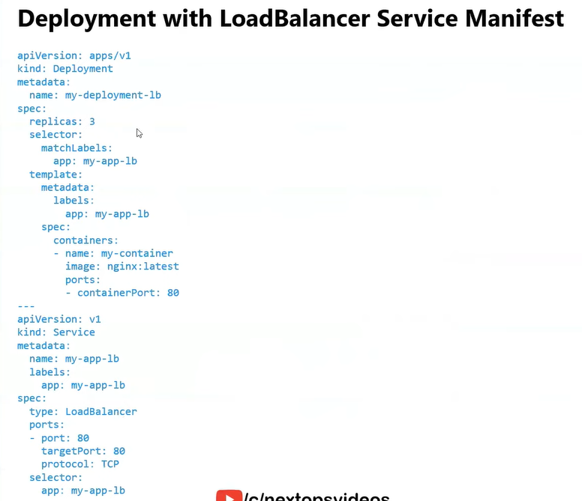

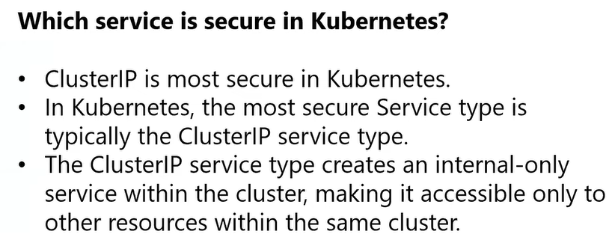

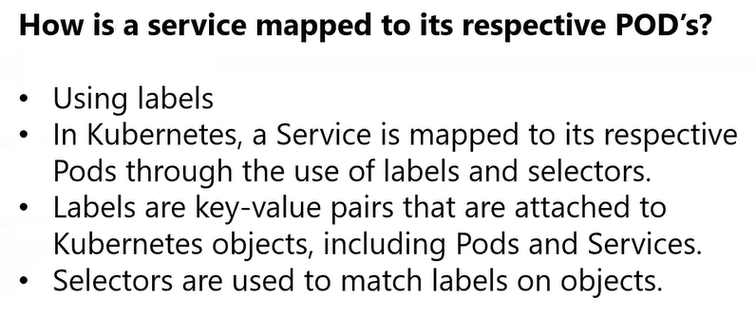

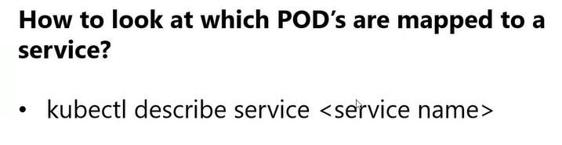

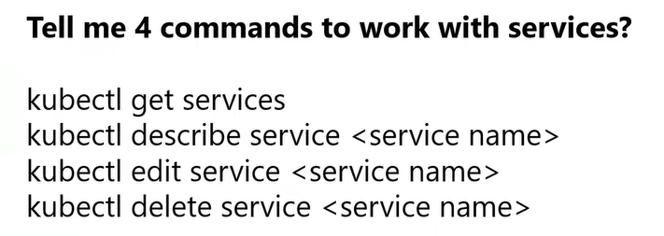

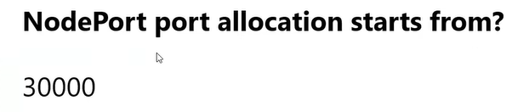

**Now practice the Lab:**

1. **Cluster IP service deployment:**

Check the ip address of the pod created already using -o wide cmd. (-o wide means output = wide)

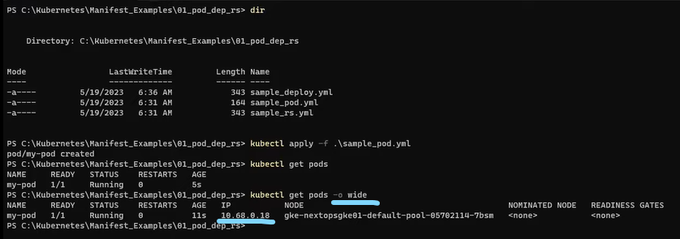

Now delete this pod and create new pod and observe the new IP address of the pod.

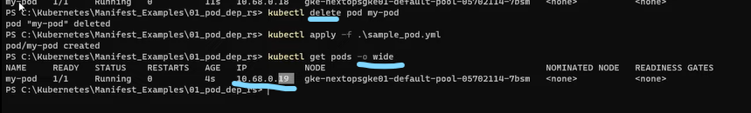

Now create deploy and do the same as above and observe the new IP address of the pod.

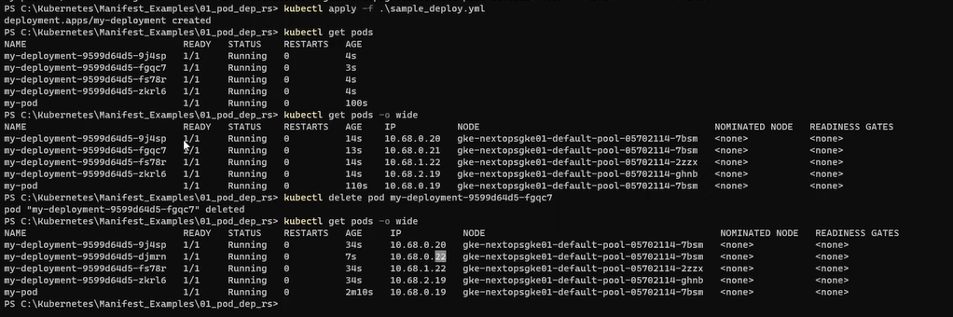

Now create the cluster IP service. (Refer the above cluster IP service manifest file)

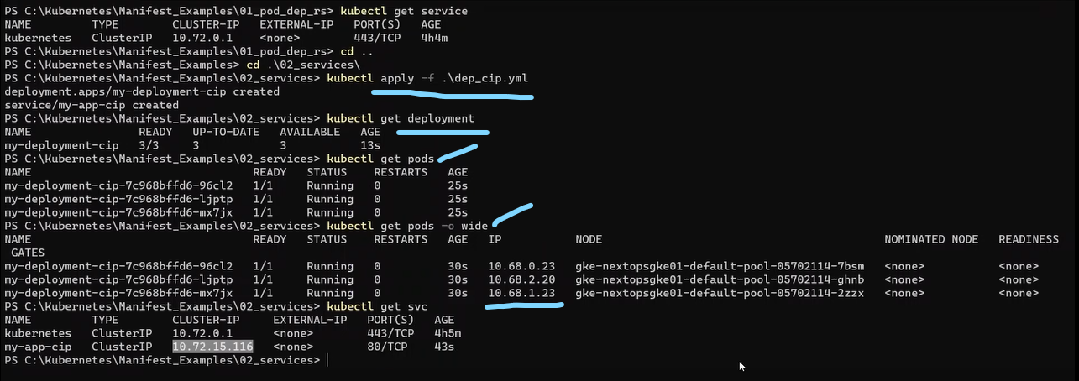

Now see how the ip address mapping done from service to pods using ‘describe’ command.

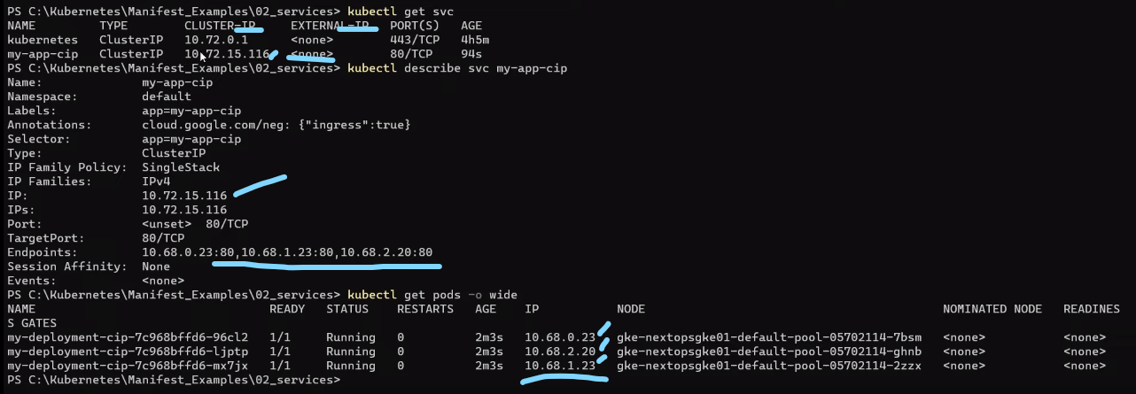

As seen above cluster Ip service doesn’t have external ip but only cluster ip, so we can’t expose our pods to outside, it’s within the cluster communication.

1. **Node port service deployment**

Now try to deploy node port service. (Refer the above node port service manifest file)

Node port is used to expose the pods to outside world.

Node port service deployment is used only for dev and QA.

Here observe the nodes have 2 ips i.e. INTERNAL-IP (for internal cluster communication) and EXTERNAL-IP nothing but public IP (for outside world via internet)

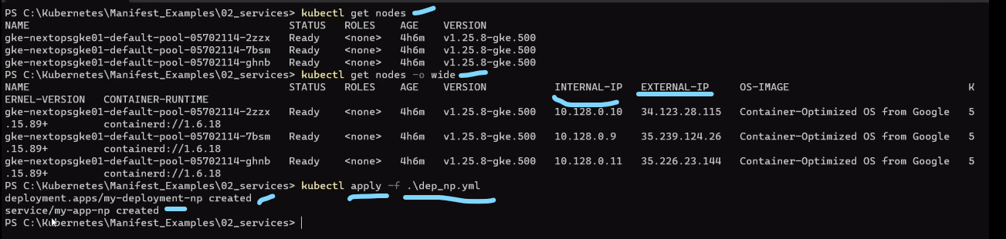

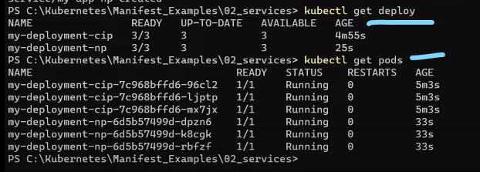

How to access the application outside via internet using node port?

1. By using EXTERNAL-IP of the node and Port of the Nodeport. The port no is always > 30000.

Here in our demo node port = 34.123.28.115:31217

Please observe below:

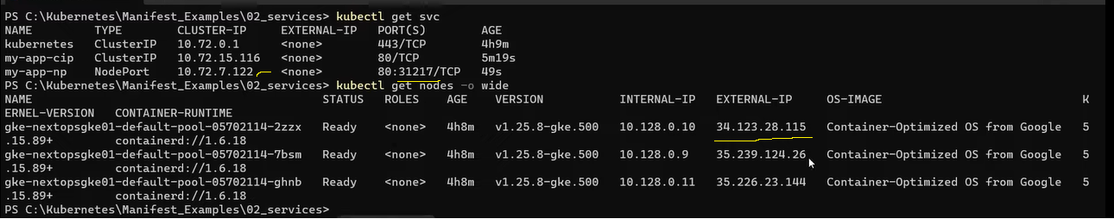

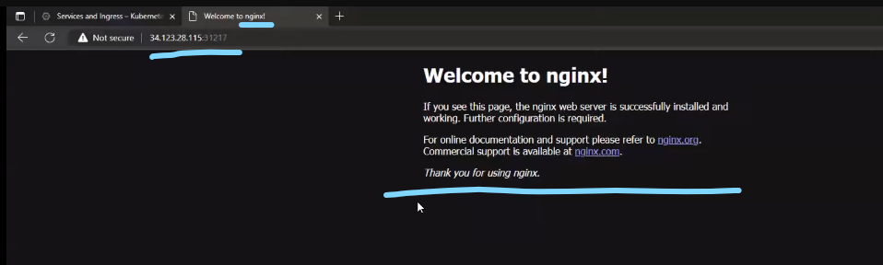

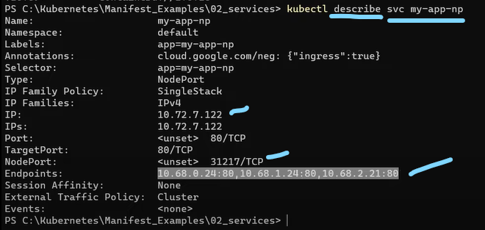

1. **LB service deployment:**

Here EXTERNAL-IP is provided by cloud provider i.e GCP.

V.IMP : in the LB service deployment one Load Balancer will create in the GCP with cluster IP and EXTERNAL-IP as shown below and we can access our application from internet using this EXTERNAL-IP .

